電通二乙微處理器實驗 實驗結報

實驗名稱 | Lab11-– MCS Cloud
組別 | 第17組 | 組員 | 曹閎舜

- 實驗目的
學會如何用連接Wi-Fi
- 實驗步驟
到MCS註冊帳號
建立網頁應用程式（web application）
透過MCS REST API進行溝通
LinkIt 家族開發板、手機、瀏覽器
- 程式碼
Check1
#include <LWiFi.h>
#include "MCS.h"

char _lwifi_ssid[] = "05050422";
char _lwifi_pass[] = "87878787";
MCSDevice mcs("D5r0WA4I", "LIr5h7lFbawoVPIj");

MCSControllerOnOff led("05050962");
MCSDisplayOnOff remote("0910859851");

void setup()
{
Serial.begin(9600);

Serial.println("Connect to Wifi");
while (WiFi.begin(_lwifi_ssid, _lwifi_pass) != WL_CONNECTED) {
Serial.println("Wifi Reconnecting..");
delay(1000);
}

Serial.println("Connect to MCS...");
while (!mcs.connected()) {
Serial.println("MCS Reconnecting..");
mcs.connect();
}
Serial.println("MCS Connected!");
mcs.addChannel(led);
mcs.addChannel(remote);
while(!mcs.connected())
{
Serial.println("MCS.connect()...");
mcs.connect();
}

pinMode(7, OUTPUT);

}

void loop()
{
while (!mcs.connected()) {
mcs.connect();
if (mcs.connected()) {
Serial.println("MCS Reconnect");
}
}
mcs.process(1000);
while(!led.valid())
{
Serial.println("read LED value from MCS...");
led.value(); //取得MCS數值
}
Serial.print("done, LED value = ");
Serial.println(led.value()); //顯示出來

if (led.value() == 1) {
digitalWrite(7, HIGH);

} else {
digitalWrite(7, LOW);

}

delay(200);
if(!remote.set(led.value()))
{
Serial.print("Failed to update remote");
Serial.println(remote.value());
}

}

Check2
#include <LWiFi.h>
#include "MCS.h"

char _lwifi_ssid[] = "AA201-2G";
char _lwifi_pass[] = "iteaa201";
MCSDevice mcs("DVdDOHvm", "0vErw0AIxI1LBczl");

MCSDisplayInteger Temp("8787");

void setup()
{
Serial.begin(9600);

Serial.println("Connect to Wifi");
while (WiFi.begin(_lwifi_ssid, _lwifi_pass) != WL_CONNECTED) {
Serial.println("Wifi Reconnecting..");
delay(1000);
}

Serial.println("Connect to MCS...");
while (!mcs.connected()) {
Serial.println("MCS Reconnecting..");
mcs.connect();
}
Serial.println("MCS Connected!");

mcs.addChannel(Temp);

}

void loop()
{
while (!mcs.connected()) {
mcs.connect();
if (mcs.connected()) {
Serial.println("MCS Reconnect");
}
}
mcs.process(1000);

int sensor = analogRead(3);

Temp.set(sensor);
Serial.println("Add sensor value.");
delay(200);
}
- 實驗結果及分析
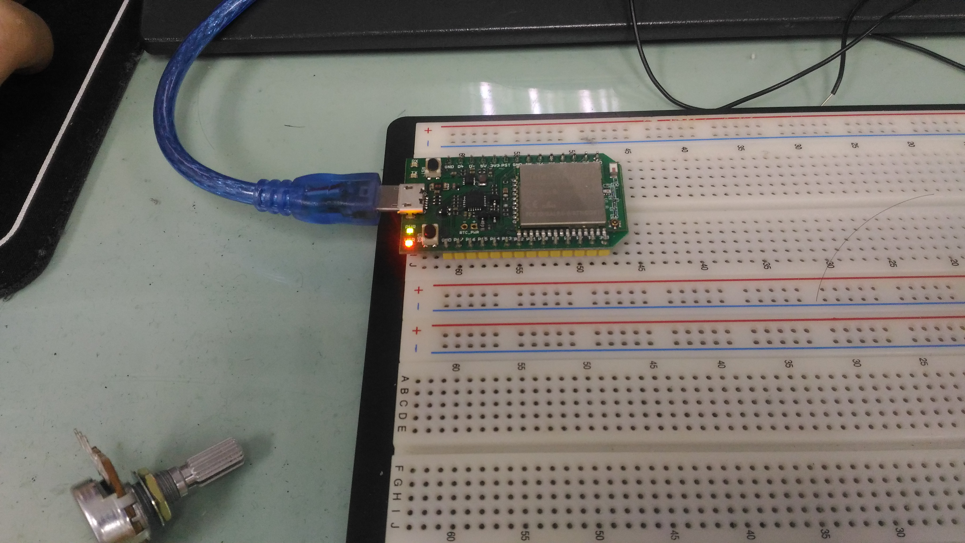
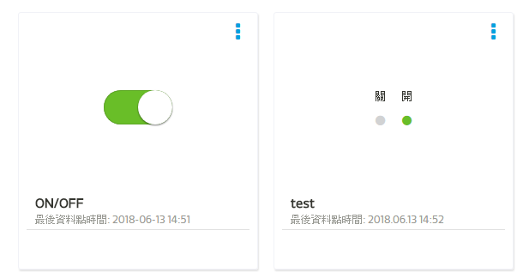

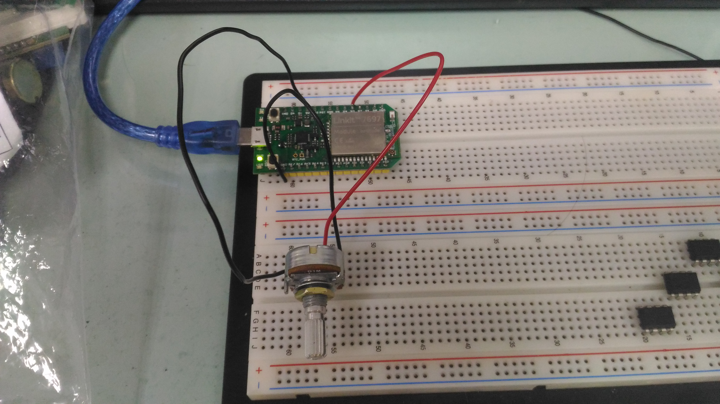
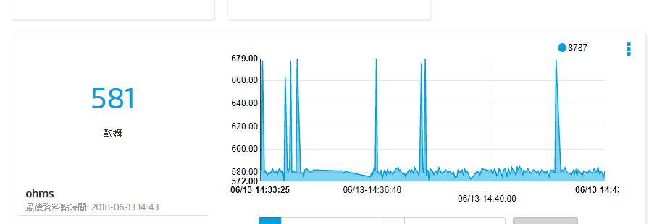
- 心得討論
這次實驗在未來可能會陸陸續續的增加。

